Papers written by Australian Maths Software

SEMESTER TWO

MATHEMATICS SPECIALIST
REVISION 2
UNIT 3-4

2016

SOLUTIONS

Section One
1. (6 marks)
(a) 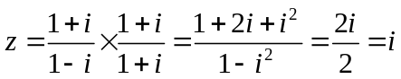
✓
(i) 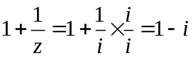
✓
(ii) 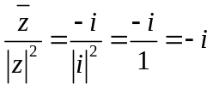
✓✓

(b) 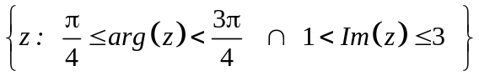
✓✓

2. (6 marks)
(a) 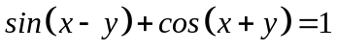
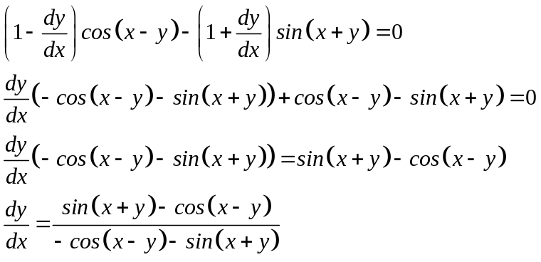
✓✓

✓
✓

(b) At 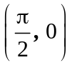 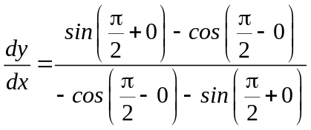
✓
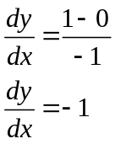
✓
3. (10 marks)
(a)
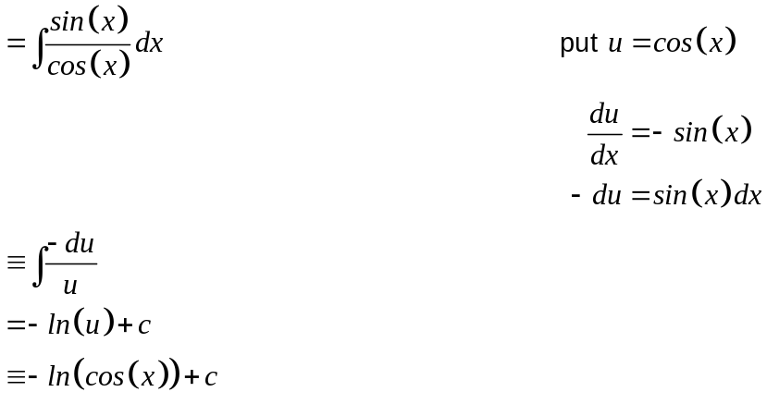
✓

✓

✓

(b) 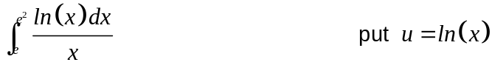
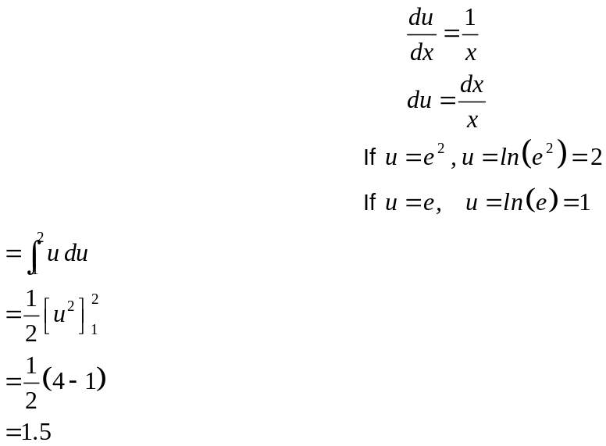
✓

✓

✓

(c)
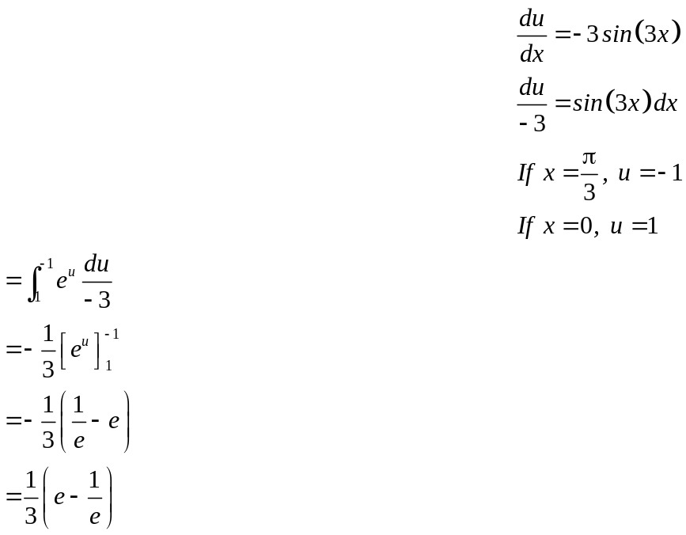
✓

✓

✓

✓

4. (3 marks)
The other four roots are 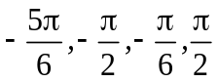
✓

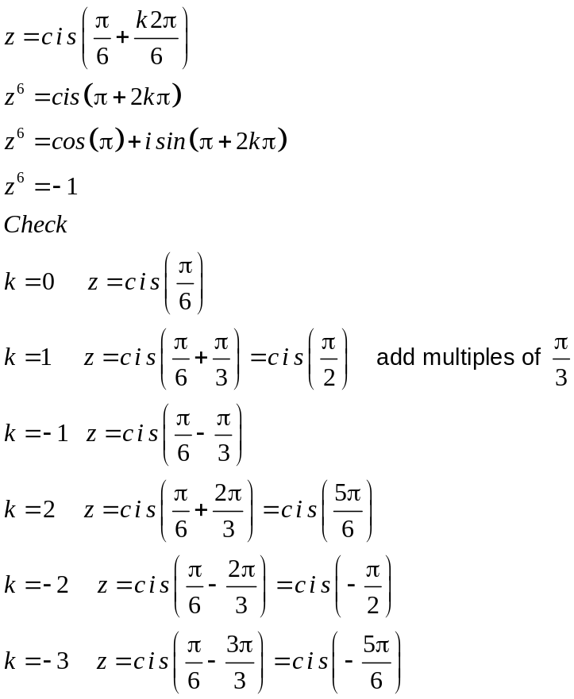
✓

✓

5. (6 marks)
(a)
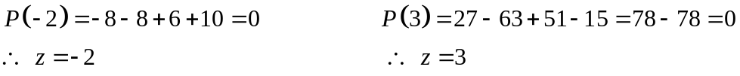
✓

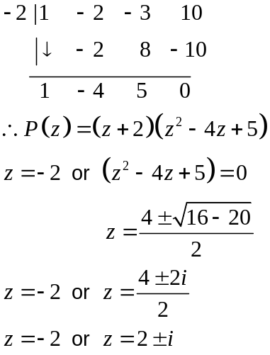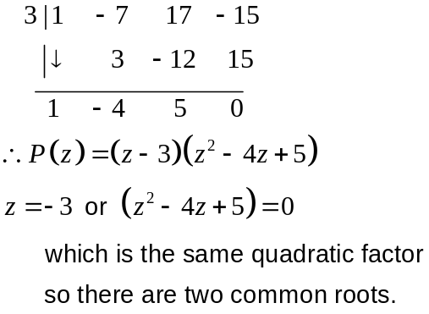
✓

✓

✓

(b) 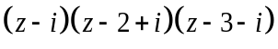
✓

✓

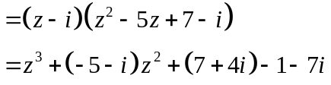
✓

6. (6 marks)
(a)
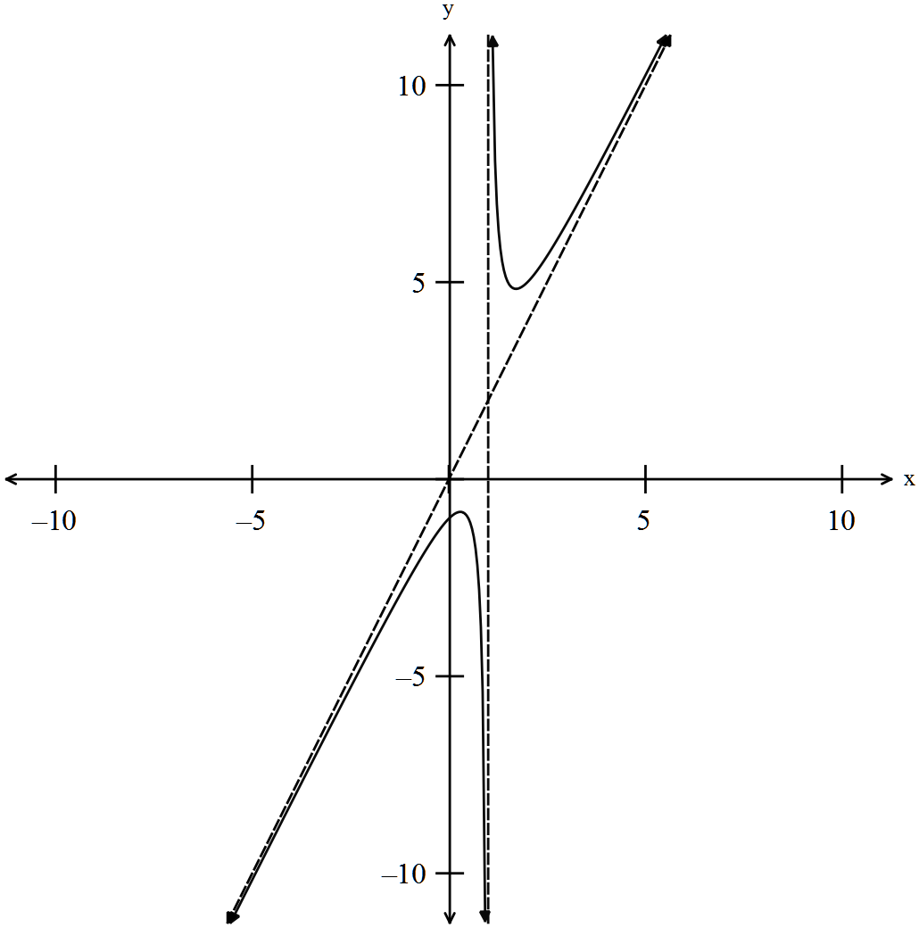✓✓✓✓
y intercept, asymptotes, no x intercept
(b)
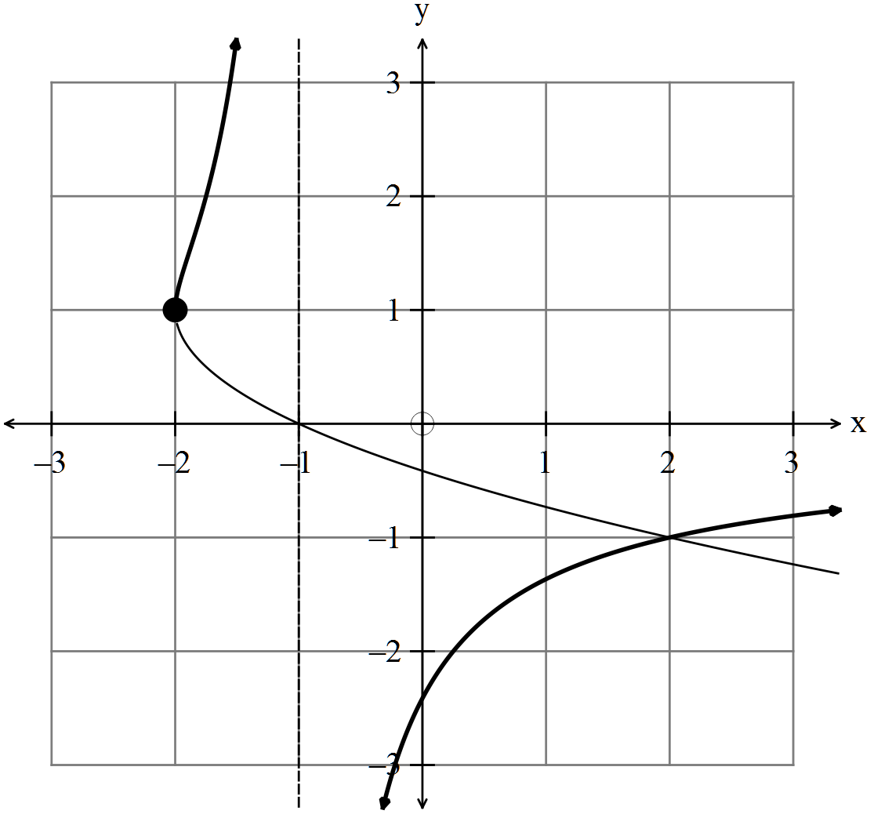
✓

✓

7. (11 marks)
(a) 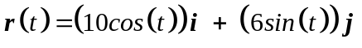
✓

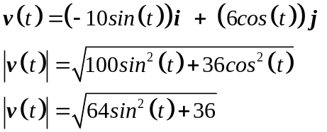
✓

✓

(b) Max speed occurs when 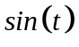= 1 and is 10 m/sec
✓

Min speed occurs when = 0 and is 6 m/sec

(c) Max :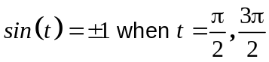 at 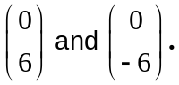 ✓
Min :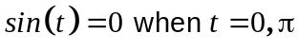 at 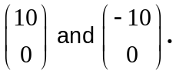
✓

(d) 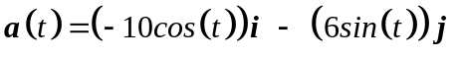
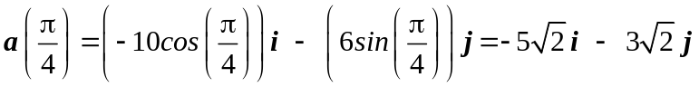
✓

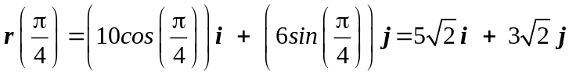
✓

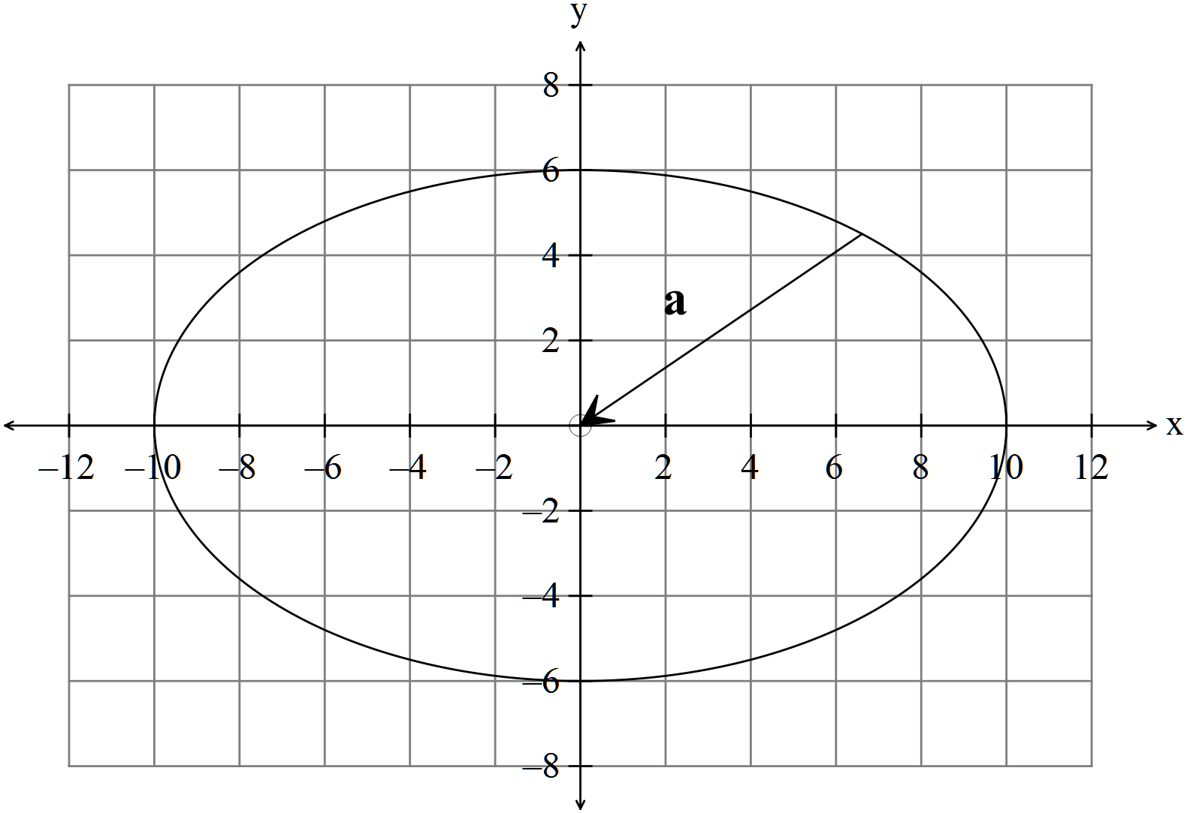
✓

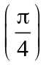
(e) 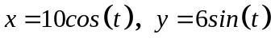
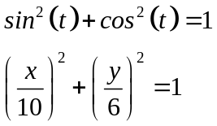
✓

✓

8 (4 marks)
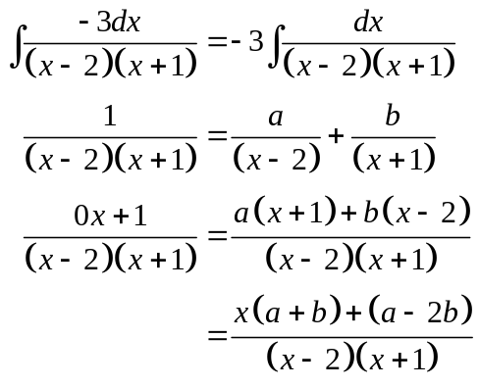
✓

✓

Equating coefficients
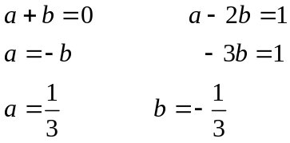
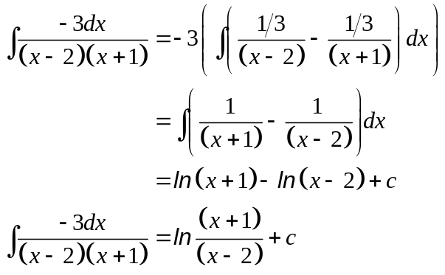
✓

✓

END OF SECTION ONE
Section Two
9. (4 marks)
(a) 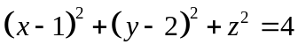
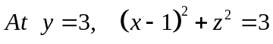
which is a circle with centre 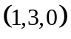with radius  and lying in the plane 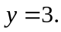
✓

✓

✓

(b)
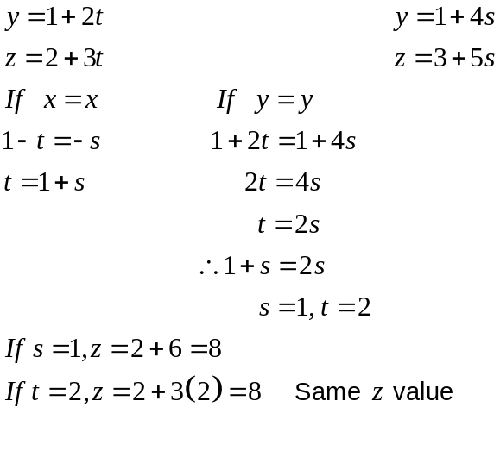
✓

✓

✓

✓

Therefore the two lines do meet, and they meet at the point P(-1,5,8)

10. (10 marks)
Given
(a) 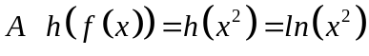
✓✓

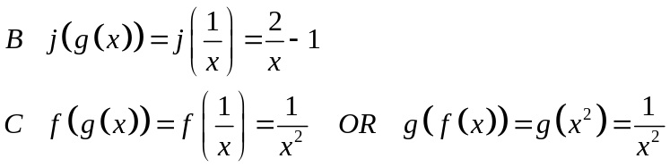
✓✓

✓✓

(b) 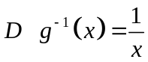
✓

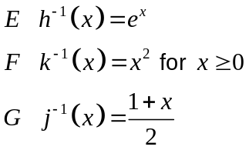
✓

✓

✓

11. (5 marks)
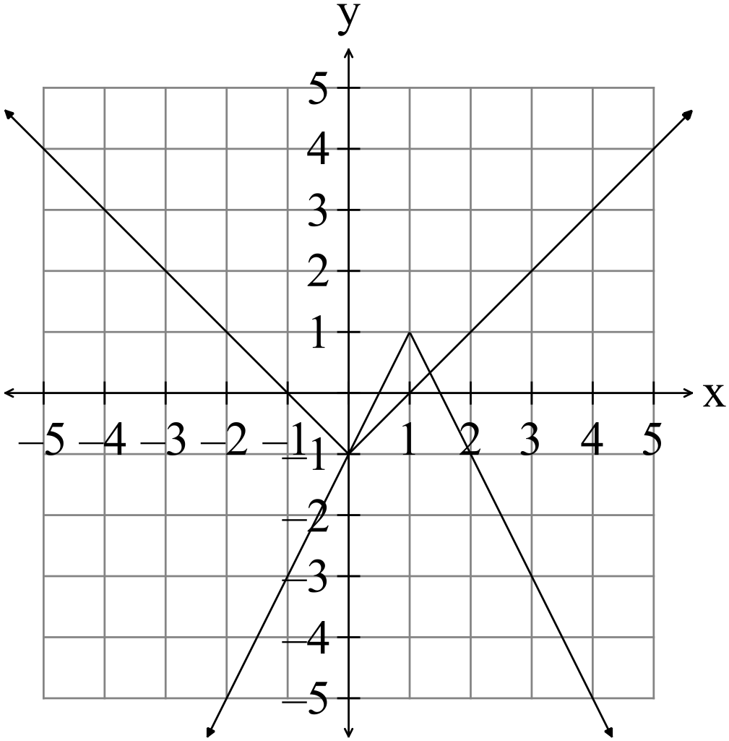Not a good method to find fractions

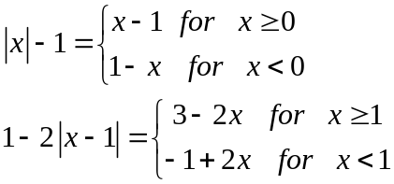
✓

✓

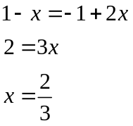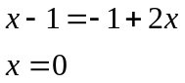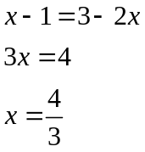
✓

✓

✓

Not in given domain

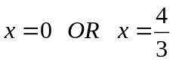
(b)
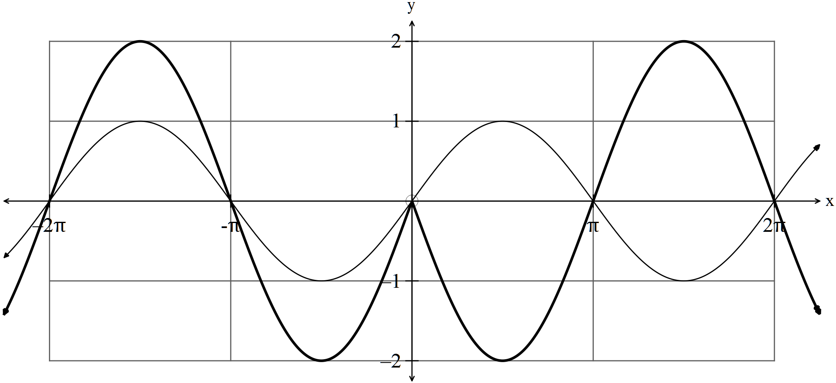
✓

✓

12. (8 marks)
(a) 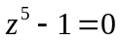
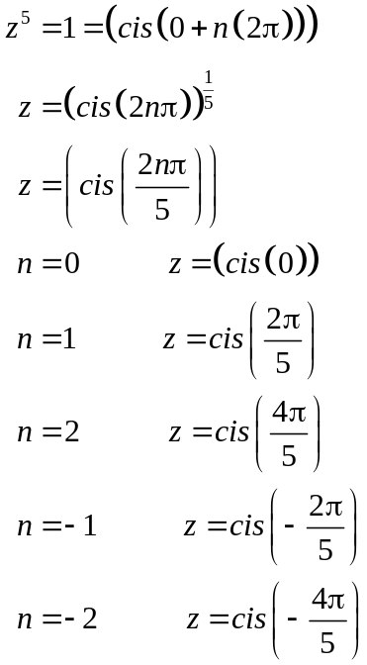
✓

✓

✓✓✓ -1/ error

(b) 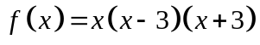 and 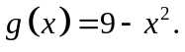
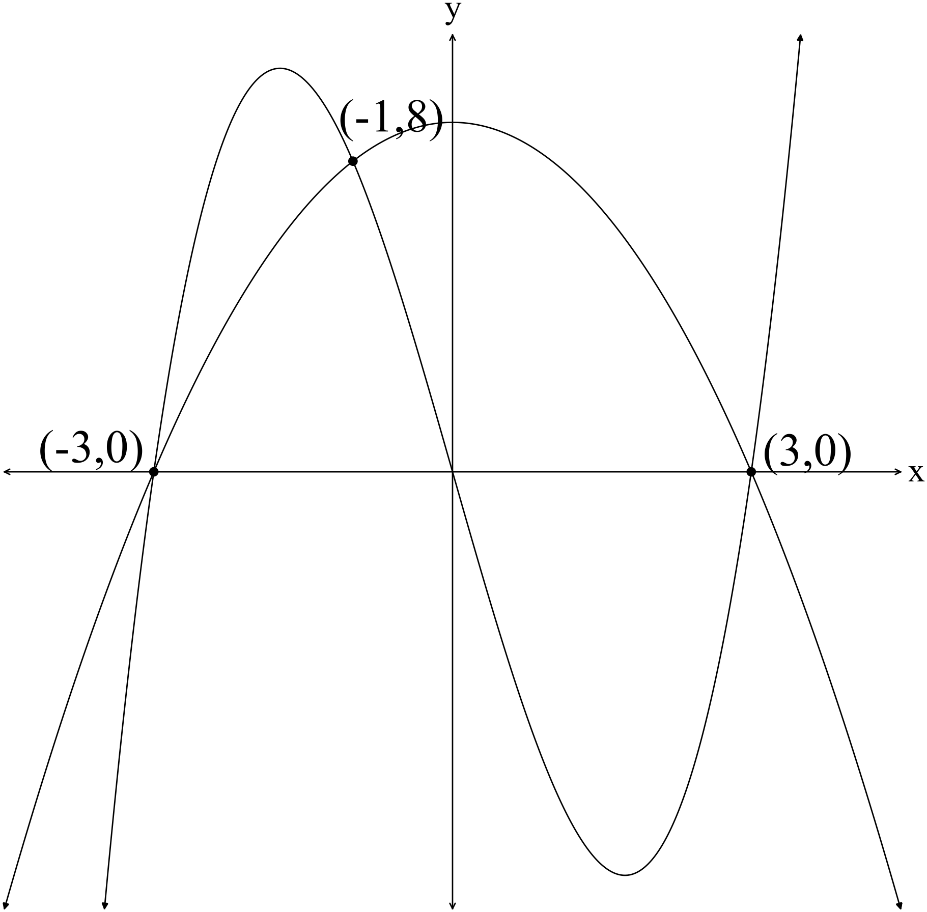

The x values of the intersection points are -3, -1 and 3 ✓
Area =
✓ ✓
OR 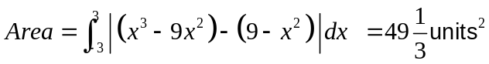
13. (9 marks)
(a) About the x axis: About the y axis
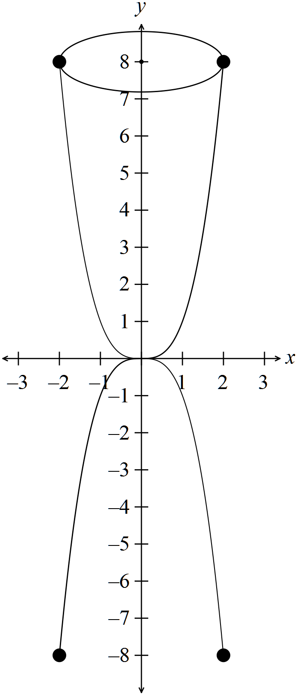 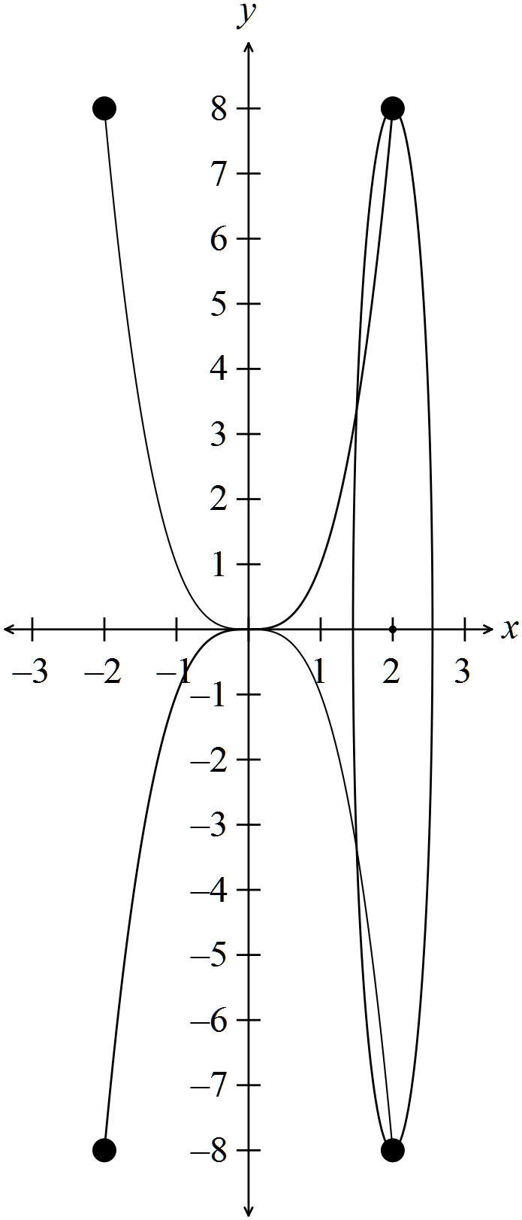✓
✓
✓✓

✓✓

There is a different shape generated so the volumes will be different.

(b) The graphs shade the same area above and below the x axis.
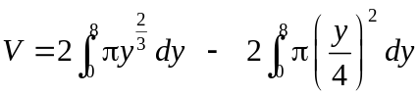
✓ ✓✓
14. (12 marks)
(a) (i) 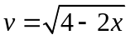
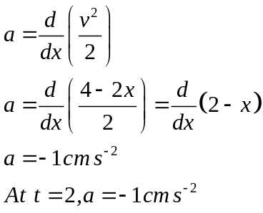
✓
✓
(ii)
✓
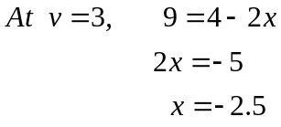
✓
(b) 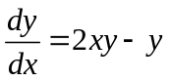
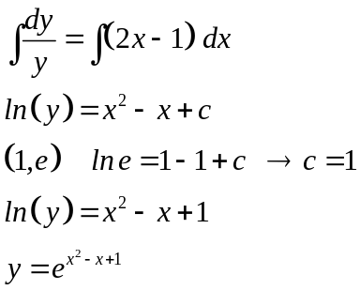
✓
✓
✓
✓

(c) 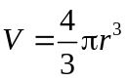
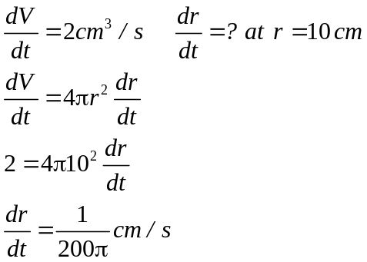
✓✓

✓
✓

15. (7 marks)
(a) 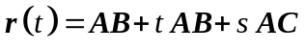
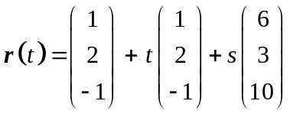 ✓✓

(b) (i) No solution where we have ✓✓
(ii) An infinite number of solutions if
✓✓
(iii) Exactly one solution if 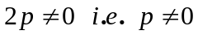 ✓

16. (8 marks)
(a) 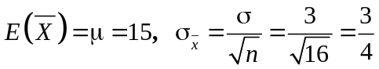
✓ ✓ ✓

(b) 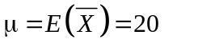
✓
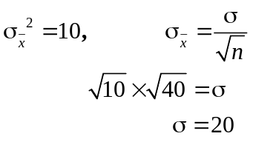
✓

(c) 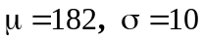
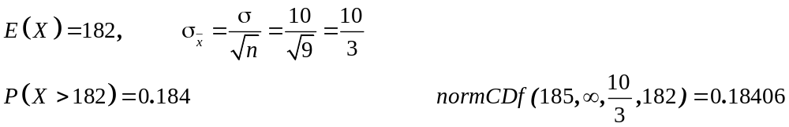
✓
✓
✓
17. (7 marks)
(a) 99% confidence limits 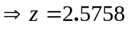
✓
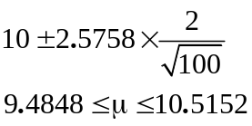
✓
✓

(b) 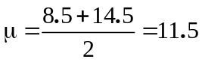
✓✓

95% confidence limits 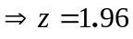
✓
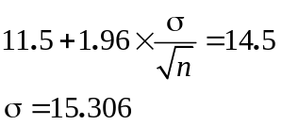 (Assume n=100 from (a))
✓

18. (12 marks)
(a) 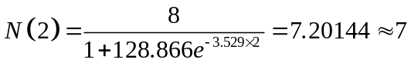
✓✓

(b) (i) 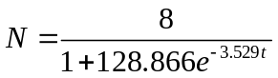
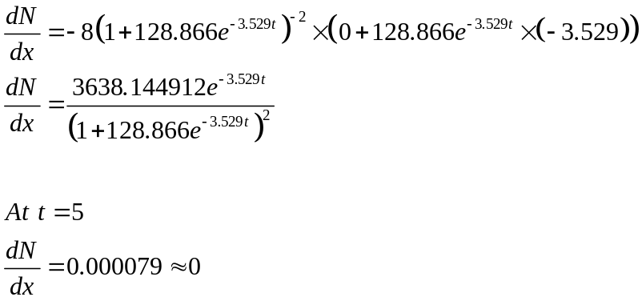
✓
✓
✓

(ii) 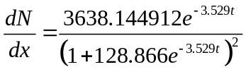
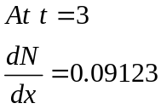
Positive so increasing.
✓
(c)
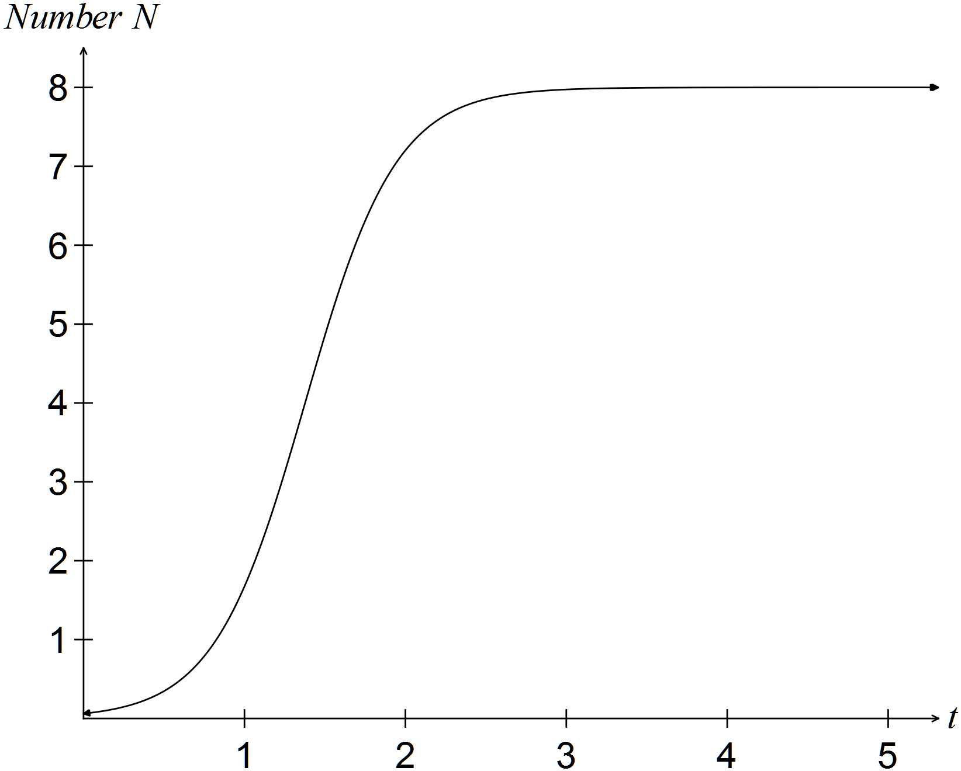
✓
✓
19. (4 marks)
(a) 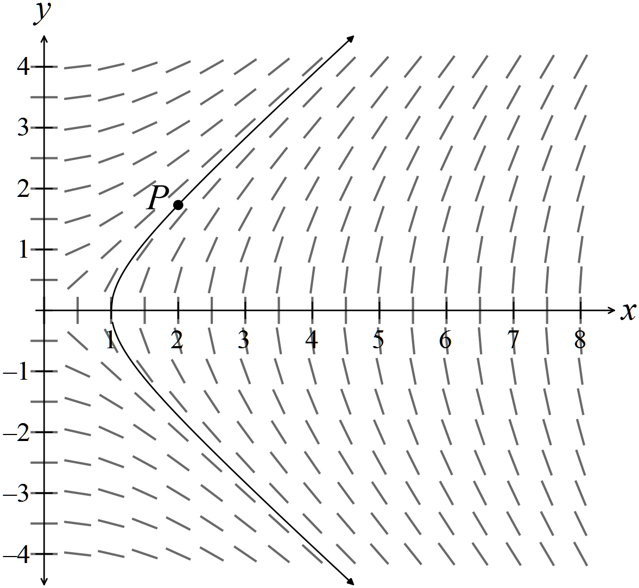

(b) The shape of the graph changes as the starting point changes.
At (4,0), the gradient is not defined. At (4,1), the gradient is steep, but becoming
less steep as the y value increases; at (4,3) the gradient is close to 1
As the y value decreases from y = 0, the slope changes from undefined to close
to -1.
✓✓

20. (11 marks)
(a) 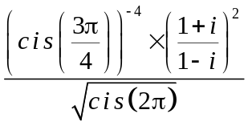
✓
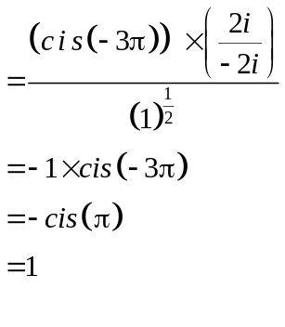
✓
✓
✓

(b) Prove that

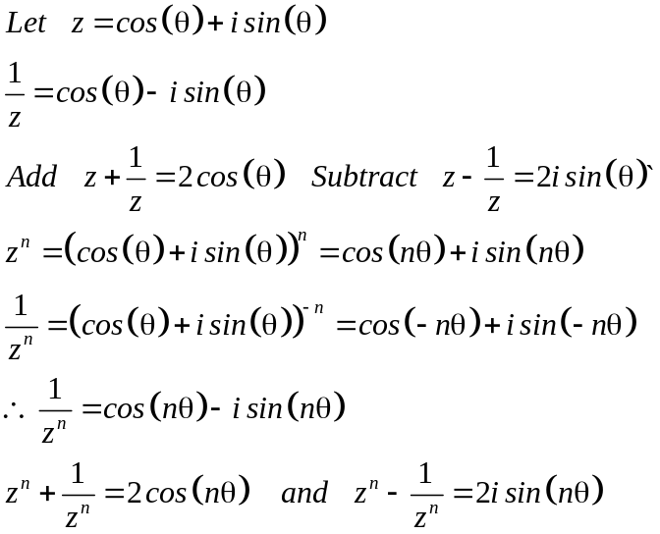
✓
✓
✓
✓

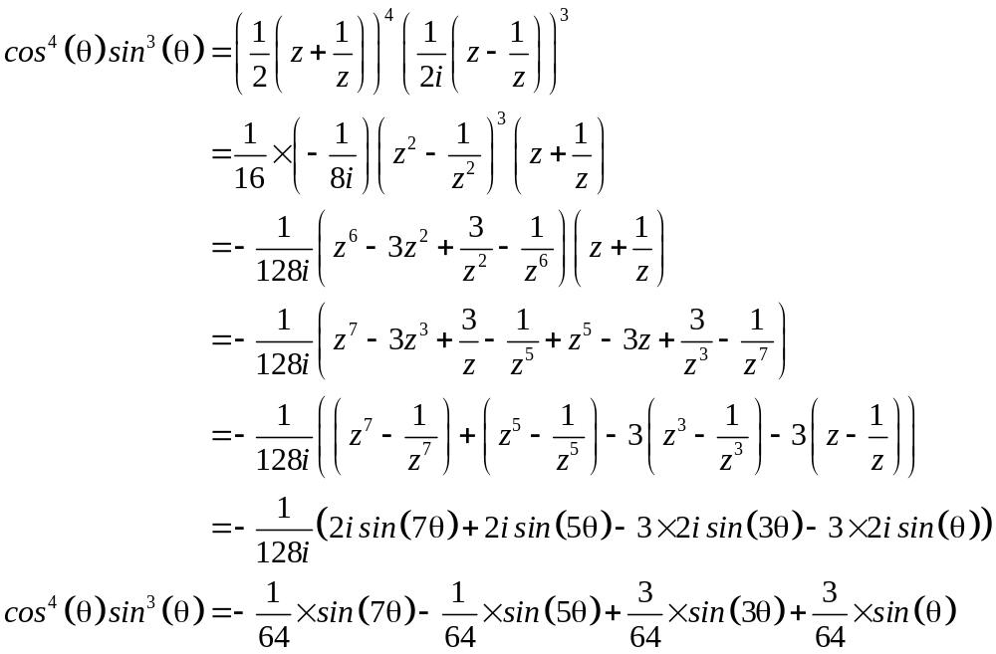
✓
✓
✓

END OF SECTION TWO

